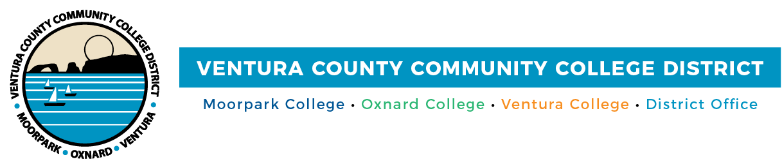

VCCCD Opts-Out of California Community College Association
Spring I Season

FOR IMMEDIATE RELEASE

Camarillo, Calif. (December 17, 2020)—After careful consideration and in the best interest of our student athletes, coaches and athletic staff of Moorpark, Oxnard and Ventura colleges, the Ventura County Community College District (VCCCD) has decided to “opt out” of competition for the upcoming California Community College Association (CCCAA) Spring I season at this time, a decision that affects traditional fall and winter sports. The VCCCD programs affected by this decision are football, men's and women's soccer, men's and women's basketball, men's and women's water polo, men's and women's cross country, women's volleyball, men’s wrestling and women’s golf.

No decision has been made for Spring II sports. The CCCAA COVID-19 contingency plan calls for Spring II sports to potentially have competition beginning in mid-April. The Spring II sports at the three Ventura County community colleges include baseball, softball, men's and women's track and field, men's and women's tennis, men's and women's swimming and diving, women’s beach volleyball, men's volleyball and men’s golf. The CCCAA deadline to “opt-in” or “opt-out” of the Spring II portion of the athletic season is Feb. 26, 2021. VCCCD leadership plans to hold meetings in January and early February to discuss the potential of moving forward with Spring II sports.

“Many adjustments have been required since March 2020. COVID-19 pandemic conditions are escalating now. We look forward to the use of ongoing safety practices and the availability of vaccines to help reduce risk and pandemic levels so that athletic competition can resume in future months,” stated Chancellor Greg Gillespie. “The health and safety of our student athletes and employees remain paramount in decision making. The creative and dedicated work of coaches and Athletic Directors keeps students engaged under challenging circumstances.”

CCCAA sports competition came to an abrupt end in March 2020 when the COVID-19 pandemic forced a shutdown in the state. Western State Conference titles were not awarded in the Spring 2020 sports, which played abbreviated regular/conference seasons. VCCCD will continue to monitor the situation as new information is released from Ventura County Public Health.

About Ventura County Community College District

The Ventura County Community College District is a member of the 116-campus California Community College system and serves approximately 31,000 students annually. The District's three colleges--Moorpark, Oxnard and Ventura--offer programs in general education for degrees and certificates, transfer to four-year colleges and universities, career technical education, and provide opportunities to engage in co-curricular campus activities. For more information, please visit vcccd.edu.

Media Contact:
Patti Blair
Director, Public Affairs and Marketing
Ventura County Community College District
communications@vcccd.edu

