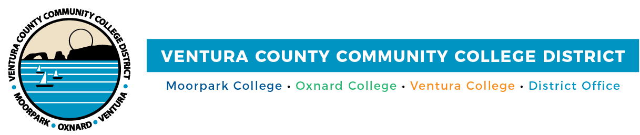

FOR IMMEDIATE RELEASE

VCCCD Appoints Cynthia Herrera as Associate Vice Chancellor
of Strategic Partnerships, Enrollment, and Advancement
Herrera brings a wealth of experience to her new role

Camarillo, Calif. (October 6, 2020)—With a strong background in business and educational leadership, Dr. Cynthia Herrera has been named the Associate Vice Chancellor of Strategic Partnerships, Enrollment, and Advancement at the Ventura County Community College District (VCCCD). In her new role, Herrera will oversee all aspects of workforce development programs, grants and other academic and student support initiatives.

“Dr. Herrera has been integral in strengthening and building our partnerships with the business and industry community in the county, which has created high-quality educational opportunities for our students,” said Board Chair Bernardo M. Perez.
Herrera joined VCCCD in 2009. Most recently, she served as the Dean of Strategic Partnerships and Planning at the District, managing economic development and partnering with Moorpark, Oxnard and Ventura colleges to improve career education opportunities for the District’s approximately 31,000 students.

She has also worked at Oxnard College, where she was the Dean of Institutional Effectiveness. She served as the Accreditation Liaison Officer, using her collaborative, leadership and organizational skills, while building the institutional effectiveness systems to support program review. Herrera worked to build institutional capacity and enhanced student success through continuous substantial improvement.

A skilled grant writer, Herrera obtained over $35 million in U.S. Department of Education and State of California grants, assisting in the development of Oxnard College’s student support systems, as well as promoting and advancing STEM (science, technology, engineering and math) programs for Hispanic and other under-represented student populations. The grants facilitated first-year experience programs, funded dual enrollment and outreach programs and provided millions of dollars to support the development of STEM curriculum and a STEM Center.

“Throughout her tenure with the District, Dr. Herrera has helped us develop strong partnerships with our K-12 partners, industry leaders, parents, community-based organizations and university partners,” said Chancellor Greg Gillespie. “She has consistently sought out increased responsibility and challenges, and has demonstrated exceptional leadership in every position.”

Prior to joining VCCCD, Herrera assisted large organizations for over 20 years in developing resource and business management systems to promote efficiency, success and sustainability.

She earned her bachelor’s and master’s degrees from Western Michigan University and her doctorate from the University of La Verne. A longtime Oxnard resident, she sits on multiple advisory boards and is involved with many community nonprofits and educational committees.

About Ventura County Community College District
The Ventura County Community College District is a member of the 116-campus California Community College system and serves approximately 31,000 students annually. The District's three colleges--Moorpark, Oxnard and Ventura--offer programs in general education for degrees and certificates, transfer to four-year colleges and universities, career technical education and provide opportunities to engage in co-curricular campus activities. For more information, visit vcccd.edu.
###
Media Contact:
Patti Blair
Director, Public Affairs and Marketing
Ventura County Community College District
communications@vcccd.edu

