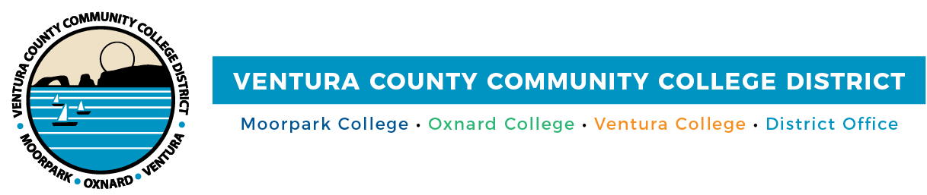

Cash 4 College
Workshops Help Students Access Funds for College

(CAMARILLO, Calif.) October 2, 2020 – To help students overcome the challenge of paying for college, the Ventura County Community College District is holding free Cash 4 College workshops for its four campuses via Zoom. Workshops will be held on Oct. 10 and Oct. 24 and you can drop in anytime during the session (details below). Financial aid staff will assist students in completing applications for the 2021-2022 school-year FAFSA (Free Application for Federal Student Aid) and the California Dream Act. The workshops are free and open to the community; people may attend workshops for any campus via Zoom on either date.

Advanced registration is preferred. For more information, visit vcccd.edu/cash4college
Moorpark College
Saturday, October 10
Saturday, October 24

9:00 am to 11:00 am

Zoom link: bit.ly/cashforcollegeMC
Join from PC, Mac, Linux, iOS or Android

Oxnard College
Saturday, October 10
Saturday, October 24

9:00 am to 1:00 pm

Zoom link: bit.ly/cashforcollegeOC
Join from PC, Mac, Linux, iOS or Android

Ventura College and Ventura College East Campus
Saturday, October 10
Saturday, October 24

9:00 am to 1:00 pm

Zoom link: bit.ly/cashforcollegeVC
Join from PC, Mac, Linux, iOS or Android

About Ventura County Community College District
The Ventura County Community College District is a member of the 116-campus California Community College system and serves approximately 31,000 students annually. The District's three colleges--Moorpark, Oxnard and Ventura--offer programs in general education for degrees and certificates, transfer to four-year colleges and universities, career technical education and provide opportunities to engage in co-curricular campus activities. For more information, visit www.vcccd.edu.
###
Media Contact:
Patti Blair
Director, Public Affairs and Marketing
Ventura County Community College District
communications@vcccd.edu

