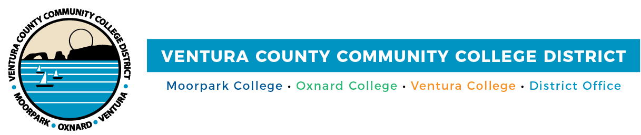

FOR IMMEDIATE RELEASE

VCCCD Announces Spring Semester Will Be Remote
District practices utmost precaution to keep its approximately 31,000 students safe

(CAMARILLO, Calif.) September 22, 2020 – Ventura County Community College District announces that due to the ongoing threat of COVID-19, a majority of its classes at Moorpark, Oxnard and Ventura colleges will continue to be remote for the spring 2021 semester, which begins Jan. 11. Strict protocols will still be in place for students and faculty who must be on campus for courses that cannot be remote.

In making the decision, VCCCD leadership carefully explored the issue and prioritized the health and safety of its approximately 31,000 students and 1,700 employees during the pandemic. The District will continue to monitor pandemic conditions and state and local Department of Public Health guidelines and restrictions and make adjustments to work status and access to the colleges as appropriate.

“We are alerting students, employees and the community of our actions now to enable everyone to plan for the future,” said Chancellor Greg Gillespie. “Our faculty at all the colleges has worked hard to adapt the curriculum for online learning so that students have an excellent learning experience.”

Continuing student registration appointment times for the spring 2021 semester will be listed on students’ MyVCCCD email portal beginning Sept. 28, 2020. New student registration begins Nov. 16. Students may register for classes at more than one VCCCD college.

“We appreciate the ongoing support of the community as we continue to take steps to protect the safety and health of our students and employees while providing educational instruction and student support,” said Board Chair Bernardo M. Perez. “We are committed to helping our students fulfill their educational and career goals.”

About Ventura County Community College District
The Ventura County Community College District is a member of the 116-campus California Community College system and serves approximately 31,000 students annually. The District's three colleges--Moorpark, Oxnard and Ventura--offer programs in general education for degrees and certificates, transfer to four-year colleges and universities, career technical education and provide opportunities to engage in co-curricular campus activities. For more information, visit www.vcccd.edu.
###

Media Contact:
Patti Blair
Director, Public Affairs and Marketing
Ventura County Community College District
communications@vcccd.edu

