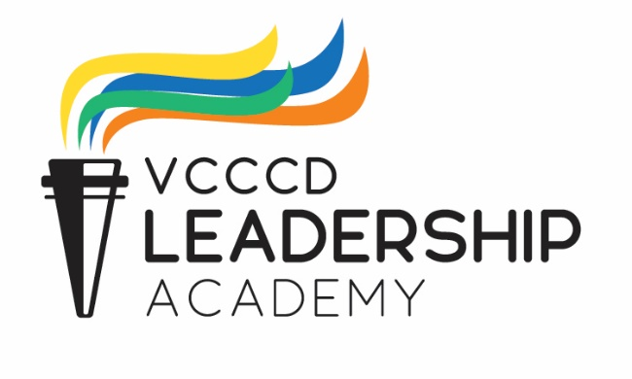

VCCCD Leadership Academy
Application – Fall 2019

Name:_______________________________________________________________________________

Current Position: _____________________________ Department: _____________________________

Office Phone: ________________________________ Email: __________________________________
Instructions:

- Submit the completed application and resume to the District Professional Development Office via email to Lbrower@vcccd.edu no later than Friday, August 16, 2019. Please write Leadership Academy Application for «your name» in the subject line.

- Provide a Statement of Support to your Immediate Management Supervisor and have them submit it directly to lbrower@vcccd.edu, no later than Friday, August 16, 2019.

Note: All District employees are encouraged to apply for the Leadership Academy. The goal is to have a cohort that is inclusive and reflects the diverse backgrounds and experiences of District employees.

Criteria

Yes, I am committed to VCCCD’s mission, vision, and purpose.
Yes, I want to advance my leadership competencies.
Yes, I have been with VCCCD for at least one full year.
Yes, I am a classified staff, faculty, or manager.

- Please attach your resume that includes:
Experience:
  - Service to College (e.g., service on committees, task forces, associations, recruitment activities, student activities etc.)
  - Personal and Professional Development Activities (e.g. workshops attended/presented, conferences attended, memberships in professional organizations)
  - Honor and Awards (e.g. recognition/appreciation)
- Please provide three examples of your leadership experience that you are most proud of:

- How would you characterize (describe) the leadership you provide on a daily basis in your current position? How does your role directly or indirectly support student success/student experience?
Professional Development Plan:
- Why do you want to participate in the Leadership Academy? What do you expect to gain from this experience?

- What department/area or skillset do you most want to learn about?

- What changes do you want to see in yourself after participating in this program?

- What three characteristics do you have that would make you a great contributor to this program?

- Describe something you want to do that you do not have the skills for right now.

- If you could wave a magic wand and put yourself in charge of an initiative at the Campus/District, what would your chosen title/area/scope of responsibility be, and why do you want to do that?

- What else do you want the Chancellor’s Cabinet members to know about you?
Personal Statement:
Use this section to share something about yourself that might help us distinguish you from other equally qualified candidates.

I understand that if I am selected as a participate in the VCCCD’s Leadership Academy:

- I am expected to attend and fully participate in all sessions.
  - Session dates are as follows:
- Session 1 – September 13, 2019
- Session 2 – October 11, 2019
- Session 3 – November 8, 2019
- Session 4 – December 13, 2019
- Session 5 – January 17, 2020
- Session 6 – February 21, 2020
- Session 7 – March 13, 2020
- Session 8 – April 10, 2020
- Session 9 – April 24, 2020
- I will create an Individual Development Plan for personal growth.
- I will keep a reflective journal.
- I will invest my personal time for homework and other assignments.
- I will use my acquired knowledge and leadership skills to enhance the future of the Ventura County Community College District.
Signature: ______________________________________________________________________
Name: _________________________________________________________________________
Date: __________________________________________________________________________

Commitment:

