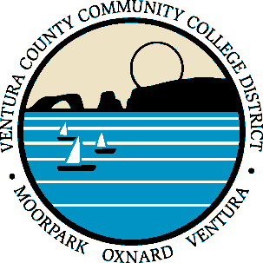
VENTURA COUNTY COMMUNITY COLLEGE DISTRICT

Institutional Research Advisory Committee

March 12, 2020 Meeting
8:30AM – 10:00AM
DAC Lakin Boardroom
805-289-6255/Conference ID: 48927

AGENDA

- Review Meeting Notes of 01/09/20

- Enrollment Management Dashboards – Presentation by John

- Committee Charge Review

- Continued Discussions
- IRB Status
- Survey Planning

- Other Business

- Next Meeting (April 9, 2020)

