FOR IMMEDIATE RELEASE

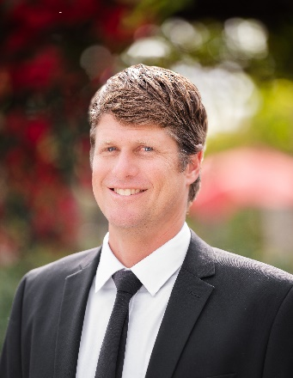 | 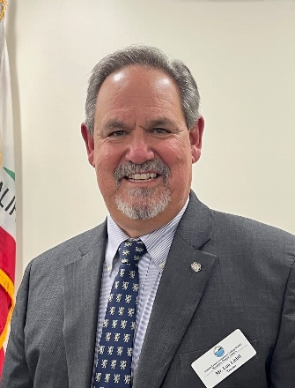 | 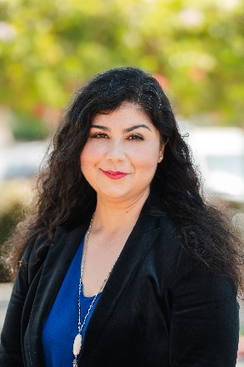
Joshua Chancer | Lou Lichtl | Gabriela Torres

VCCCD Installs Three Trustees and Elects Board Leadership
Trustees welcome newly elected educator Lou Lichtl

Camarillo, Calif. (December 22, 2022) — Longtime Ventura County resident and educator Lou Lichtl joined the Ventura County Community College District Board of Trustees during the District’s Annual Organizational Meeting on Dec. 13. Lichtl was installed with trustees Joshua Chancer and Gabriela Torres, who were re-elected in November.

At the meeting, Trustee Bernardo M. Perez, who has served on the board of trustees since 2010, was elected board chair. Torres was elected vice chair, and Chancellor Rick MacLennan will serve as secretary.

“I look forward to working with my fellow trustees to continue our commitment to bettering the lives of students at Moorpark, Oxnard and Ventura colleges and strengthening our partnerships with the community,” said Perez, who is serving his fourth term as chair over his 12 years on the board. He has a long history of dedication and involvement in Ventura County, having served previously as mayor of the City of Moorpark and a member of the Moorpark City Council.

The five-member board of trustees, which also includes Trustee Stan Mantooth, works collaboratively to adopt policies that oversee all activities relating to the business of the District and Moorpark, Oxnard and Ventura colleges. Student Trustee Azure Heirshberg advocates on behalf of VCCCD students.

Ventura County voters elect trustees in even-numbered years to four-year terms. The student trustee is elected annually through a district-wide student election.

Lichtl is the Area 2 representative, which encompasses Thousand Oaks, Newbury Park, Westlake Village (Ventura County portion), Oak Park, Lake Sherwood, Hidden Valley, Santa Rosa Valley and portions of Camarillo.

A retired public school educator of over 35 years, Lichtl is currently the administrator of Passageway School, a non-public school for students with disabilities in Newbury Park. Lichtl’s experience as an educator and administrator has provided him with extensive experience in policy development, budget oversight and community building.

“As a product of the community college system and the son of Cuban political refugees, I feel a great honor in having been elected to the VCCCD board of trustees,” said Lichtl. “This is a responsibility I do not take lightly, and I am ready to get to work on behalf of the students and classified staff within our college system.”

Chancer will continue to represent Area 1, which includes Ventura, Saticoy, Montalvo, portions of El Rio, Ojai Valley, City of Ojai, Riverpark, Northwest Oxnard, Meiners Oaks, Wheeler Springs, Oakview and North Coast. He has over 20 years of experience in public education, teaching English language arts, social science and adult ESL. His dedication to students has earned him several awards and recognition as an educator, including the Pacific Teacher Innovation Network Award and Grant.

Torres was first elected to the VCCCD board of trustees in 2018. She is an administrator for the Oxnard School District and committed to social justice issues and serving students. Torres represents Area 5, which covers CSU Channel Islands, Colonia, Mandalay Bay, Silver Strand, Hollywood Beach and Hollywood by the Sea, Channel Islands Harbor, Port Hueneme, Oxnard Plain, Naval Base V.C. Port Hueneme and portions of El Rio.

“The District leadership and board of trustees are committed to laying a foundation for academic and career success for Ventura County students,” said MacLennan. “The District has a rich history of serving diverse communities and creating opportunities for students to thrive. I look forward to working with the board to further the mission of the District and our colleges.”

The next board of trustees meeting is Jan. 17, 2023, at the Ventura County Community College District Administrative Center and live-streamed by Zoom. Detailed information regarding board meetings is available at vcccd.edu/board-of-trustees.

About Ventura County Community College District
The Ventura County Community College District is a member of the 116-campus California Community College system and serves approximately 30,000 students annually. The District's three colleges—Moorpark, Oxnard and Ventura—offer programs in general education for degrees and certificates, transfer to four-year colleges and universities, career technical education and provide opportunities to engage in co-curricular campus activities. For more information, visit vcccd.edu.

Media Contact:
Patti Blair
Director, Public Affairs and Marketing
Ventura County Community College District
communications@vcccd.edu

