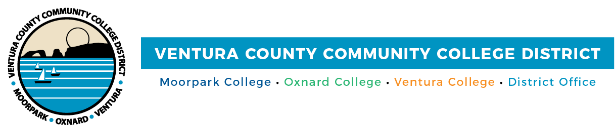

FOR IMMEDIATE RELEASE

Ventura County’s Community Colleges Named
Among Top 100 Colleges and Universities for Hispanics
Honor recognizes VCCCD colleges for their dedication to serving
Hispanic/Latino students

Camarillo, Calif. (February 25, 2022)—In recognition of Ventura County Community College District’s commitment to the success of its Hispanic/Latino students, Hispanic Outlook on Education Magazine™ named the District’s colleges among the Top 100 Colleges and Universities for Hispanics. The national magazine’s 2021 annual Top 100 issue recognized Moorpark, Oxnard and Ventura colleges in the categories of Total Enrollment for Two-Year Schools and Total Associate Degrees Granted for the 2019-2020 Academic Year.

The Top 100 list for community colleges and their enrollment of Hispanic/Latino students spans 13 states, with a majority located in California, Texas and Illinois. Each two-year college that was recognized enrolled more than 6,000 Hispanic/Latino students during the timeframe. Serving more than 7,400 Hispanic students, Moorpark College ranked 78th; Oxnard College ranked 69th, with more than 8,000 Hispanic students; and Ventura College was 37th, serving more than 11,300 students.

As designated Hispanic-Serving Institutions with many first-generation college students, the District’s colleges awarded 3,678 associate degrees to Hispanic/Latino students during the period reported. Moorpark College placed 53rd on the top 100 list by granting 1,100 degrees; Oxnard College placed 63rd with 945 degrees; and Ventura College, 27th with 1,633.

In 2021, Ventura College ranked 22 on the monthly magazine’s 2021 Top Community Colleges’ list, with 63% of students being Hispanic. Oxnard College was named to the list of Top STEM Schools for Hispanics for its number of math and statistics degrees granted in 2018-19.

All three colleges have robust programs to support Hispanic students in their educational goals and have received substantial, multi-year federal grants aimed at expanding students’ educational opportunities.

Upon learning about these honors, the District’s board of trustees and college presidents expressed their appreciation.

“The fact that each of our colleges received this recognition emphasizes the District’s ongoing investment in the academic and personal success of our Hispanic/Latino students,” said VCCCD Board Chair Dianne B. McKay. “We remain committed to empowering these students so they can achieve their goals and dreams.”

“We are grateful to Hispanic Outlook for recognizing Moorpark College’s continued efforts to connect with and inspire our Hispanic/Latino students,” said Dr. Julius Sokenu, Moorpark College president. “The successful implementation of several programs designed to assist Hispanic/Latino students to achieve their degrees has been our ongoing priority. It is with great pride that we facilitate effective programs that attract, inspire, mentor and support our students.”

“For nearly a half-century, Oxnard College has served our community as a federally recognized Hispanic Serving Institution,” said Luis Sanchez, president of Oxnard College. “We’re in the business of generational transformation and are proud of our decades-long impact in the lives of our students and their families.”

“Ventura College is proud to rank #27 in the nation for total associate degrees granted to Hispanic/Latinx students and #37th in total enrollments,” said Dr. Kim Hoffmans, president of Ventura College. “This recognition is testament to the college’s many efforts in providing exceptional educational opportunities that support our students. We are honored and further inspired to continue uplifting our Hispanic/Latinx student populations.”

Ranking information for the Top 100 lists came from the Integrated Postsecondary Education Data System/National Center for Education Statistics, a primary source for information on U.S. colleges, universities and technical and vocational institutions.

For complete listings of the Top 100 Colleges and Universities for Hispanics, visit https://www.hispanicoutlook.com/articles/top-100-colleges-and-universities-hispanics.

Ventura County Community College District
The Ventura County Community College District is a member of the 116-campus California Community College system and serves approximately 31,000 students annually. The District's three colleges—Moorpark, Oxnard and Ventura—offer programs in general education for degrees and certificates, transfer to four-year colleges and universities, career technical education, and provide opportunities to engage in co-curricular campus activities. For more information, please visit vcccd.edu.

Media Contact:
Patti Blair
Director, Public Affairs and Marketing
Ventura County Community College District
communications@vcccd.edu

