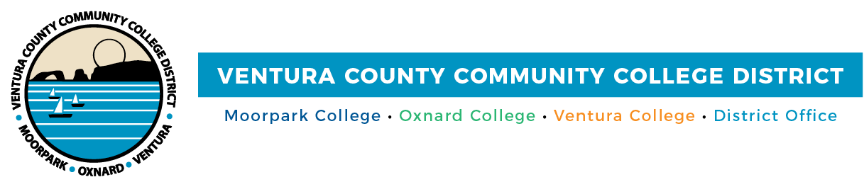

FOR IMMEDIATE RELEASE

VCCCD Board Approves Mandatory COVID-19
Vaccinations for Students and Employees
Action would follow indoor face mask requirements in the District’s public spaces

Camarillo, Calif. (August 11, 2021)—After thorough discussion and research, the Ventura County Community College District Board of Trustees unanimously approved the policy COVID-19 Vaccine Requirement for Employees and Students at its Aug. 10 meeting. The policy requires that everyone who accesses in-person, on-site campus/District programs or who participates in off-site District/college services in person will be required to be vaccinated against COVID-19. The goal is to protect the health and well-being of students, faculty, staff, administrators and the communities VCCCD serves, as well as maintain higher education access and attainment for the District’s approximately 31,000 students.

Effective Oct. 15, the mandate allows time for unvaccinated employees, students and the public to complete two-dose vaccines. The mandate recommends immediate implementation with the vaccines the Food and Drug Administration approved under Emergency Use Authorization, including those from Pfizer-BioNTech, Moderna and Janssen (Johnson & Johnson).

People with verified medical conditions or who have sincerely held religious beliefs that prevent vaccination can request an accommodation from District Human Resources.

Individuals who have not received a COVID-19 vaccination may be subject to other safety measures. Students enrolled in in-person classes for the fall semester will be required to change to online classes, if they are not vaccinated by the deadline.

“We are hopeful this mandate helps improve the vaccination rate in Ventura County, as we all hope for an end of the pandemic,” said Board Chair Joshua Chancer.

The Board is grateful for the input from Ventura County Public Health, which was incorporated into the approved policy to support achievement of population-level immunity throughout the District and Ventura County. As of Aug. 10, 66% of Ventura County residents, age 12 and above, are vaccinated (venturacountyrecovers.org/). According to experts, to bring the pandemic under control, about 85% of Americans will need to be vaccinated.

Locally and statewide, institutions of higher learning have implemented coronavirus vaccine mandates. The California Community Colleges has strongly recommended a vaccine mandate to help safeguard student/employee health and safety, and Governor Gavin Newsom’s office has ordered COVID-19 vaccination for all state employees.

“The District prioritizes the health and safety of its employees, students and the community,” said Chancellor Greg Gillespie. “This mandate, along with other COVID safety protocols we’ve been practicing since the beginning of the pandemic, will help keep our communities safe.”

The District will continue to adhere to indoor mask use following recommendations from the Ventura County Public Health department. Since mid-July, the department has urged community members to wear masks indoors in public spaces, regardless of their vaccination status, to reduce the spread of COVID and lower hospitalizations in Ventura County.

According to the Centers for Disease Control and Prevention (CDC), the Delta variant caused between 80% and 87% of all COVID-19 cases across the country during the last two weeks of July—up from 8% to 14% in early June. The CDC continues to emphasize vaccines offer strong protection against serious illness or death.

Ventura County Community College District
The Ventura County Community College District is a member of the 116-campus California Community College system and serves approximately 31,000 students annually. The District's three colleges--Moorpark, Oxnard and Ventura--offer programs in general education for degrees and certificates, transfer to four-year colleges and universities, career technical education, and provide opportunities to engage in co-curricular campus activities. For more information, please visit vcccd.edu.

Media Contact:
Patti Blair
Director, Public Affairs and Marketing
Ventura County Community College District
communications@vcccd.edu

